# NETWORK ANOMALIES DETECTOR APP USING FASTAPI

A web application named ‘Network Anomalies Detector’ is developed using FastApi by choosing the best performing model to detect whether there is Malicious activity going on in the user network data provided. FastApi, a web framework which is used to develop web application and it is written in python. React.Js is used to create the user interface, home and result age for app and it is called in Fastapi using render template function.

In chosen dataset, Model built using Gradient boosting classifier algorithms performs well in predicting the anomalies in the dataset an accuracy of 99.480. Hence, this model is selected to build Network Anomalies Detector application and it is loaded into Fastapi using load function from the ‘joblib’ library.

## 1.1 High-level steps to build and execute the application

1. Home page is created using html as furnished in the below Figure

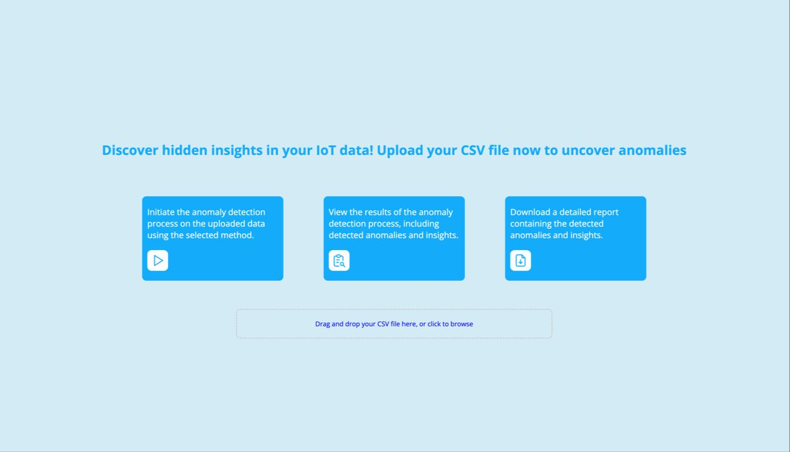

*Figure 1: Home Page*

1. When users Drag and drop your CSV file. The data must have a “Protocol” column, then it is cleaned using data_cleaning function to remove null values
2. The model will select the “Protocol” column because that is the where it is going to find the anomalies
3. The model will use a vectorizer to convert the text to float because machine learning can only predict numbers
4. Pre-processed data will be fed into the gradient boosting classifier model to predict its anomalies
5. If the model predict the data in real time and populate the dashboard

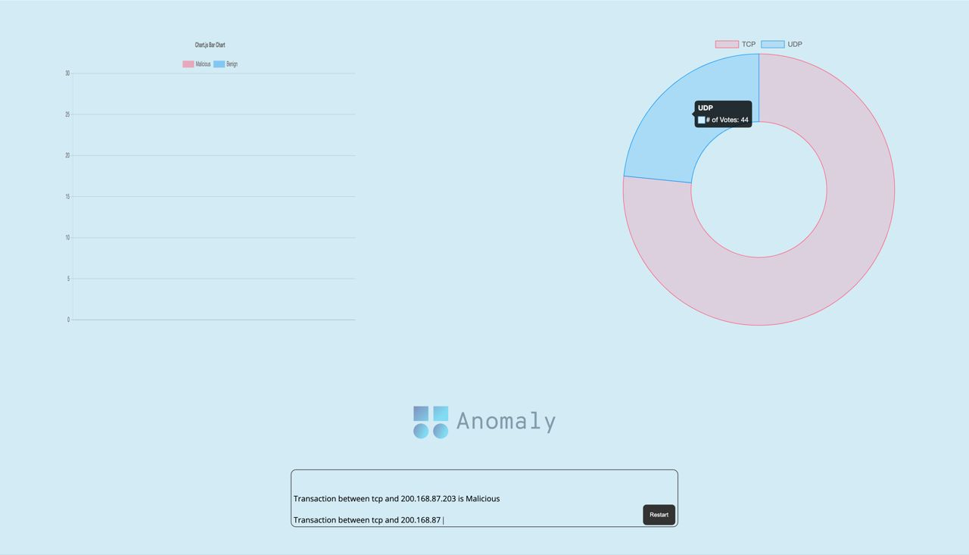

*Figure 2: predicting and populating the dashboard in real-time*

# STRUCTURES OF NETWORK ANOMALIES DETECTOR APP

1.Creating App using Flask Python

# 

2.1 homepage.js

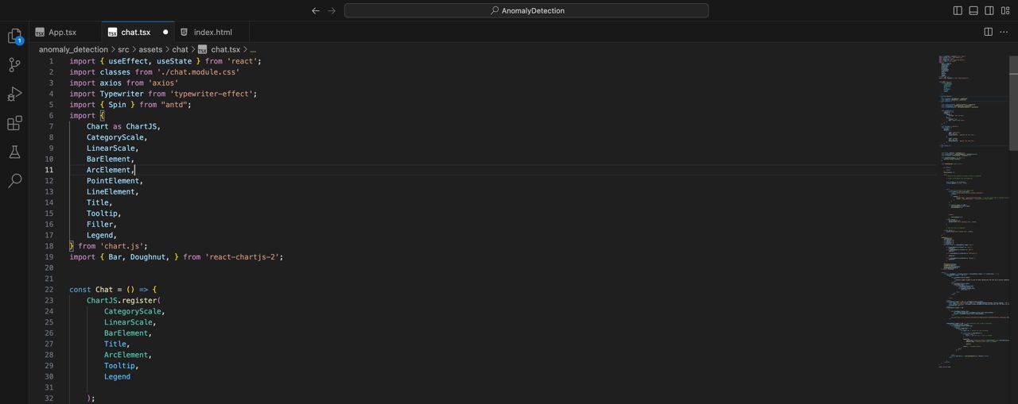

2.2 dashboard.js

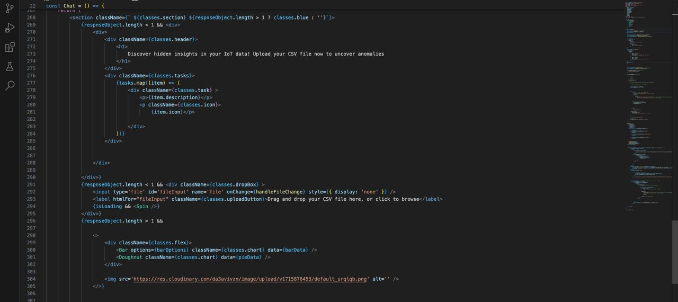

# SYSTEM REQUIREMENTS SPECIFICATIONS

* Windows 10, 64 bit
* Jupyter Notebook, version 3.9.2 is used to run implemented Machine Learning Models and Fake News Detector App available in “Network Anomalies Detection-ML Models .ipynb” and “Network Anomalies App .ipynb” python files respectively.
* Jupyter Notebook should be used to run the “Network Anomalies Detection- Complete Notebook .ipynb” file

**Structure of the network anomalies file**

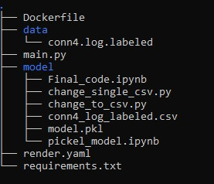

***Pre-requisite to run the “NetworkAnomalies App .ipynb” python file:***

* Place the ‘GBC model’ file produced during execution and create a Subfolder called ‘templates’ where you have placed the ‘Network anomalies Detector App .ipynb’ Python File.'GBC model' file created during my execution are attached for reference.
* Run the Network anomalies detector app.ipynb it will give you the pickled model.pkl
* Now run the main.py of the app using uvicorn main:app then you can check the anomalies
* You can also asses the app on <https://anomaly.spaces-ui.xyz/>